**CASE STUDY REPORT OF Online Shopping Portal**

Features :-

1. The main two users of the system are :- customer and administrator.
2. Customer is able to register themselves with a unique username.
3. Customer can view all the products displayed on the website without registering.
4. After registration the customer may order more than 1 item and quantity ranging from 1-5 at a time.
5. He may also keep the items in MY-CART to order them later.
6. After placing the order, the customer is given a unique order reference number. The status of the order can be checked by the customer in ORDER HISTORY section.
7. The Administrator is allowed to ship only those orders where the quantity of the items demanded satisfy the stock availability of those items. After shipping the order, the quantity demanded for the items are automatically deducted from the stocks of the respective items. He may also reject the order if he decides.
8. Administrator is also eligible to change stock values of the items with valid amount.

Description of the tables used :

1. PRODUCT_MASTER : this table is used for keeping all the details of the product; e.g- company name, category, stock available, price, etc. prodid (PRODUCT ID) is the primary key

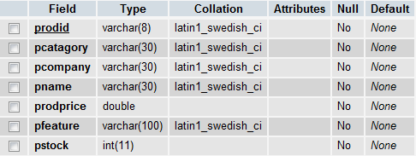

P.T.O.

1. ORDER_MASTER : this table keeps the information about the shipping address of the order, total charge, order status and remark; excluding the items ordered and its quantity. order_id(ORDER REFERENCE NUMBER) is the primary key.

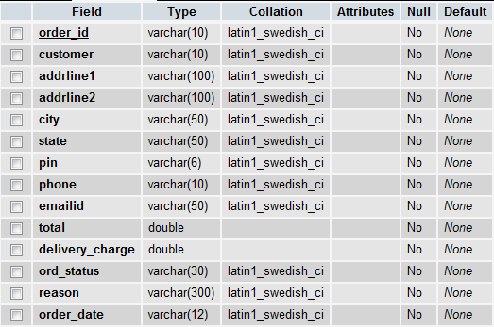

1. ORDER_DETAIL : this table is used to keep the products ordered and the quantity of them. Order(ORDER REFERENCE NUMBER) and product (PRODUCT ID) both are the primary key.

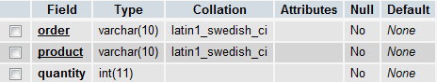

1. CUSTOMER_MASTER : this table keeps the information about the customer of the website. Custid(CUSTOMER ID) is the primary key.

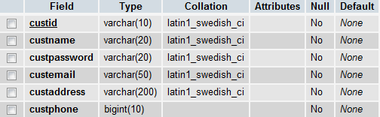

1. MYCART_MASTER : this table is maintained for holding the products selected by the customers in their respective shopping cart. customer(CUSTOMER ID) and product (PRODUCT ID) both are the primary key.

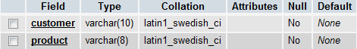

1. ADMINISTRATOR_MASTER : This table contains the username and password of the administrator module. adminname(ADMINISTRATOR NAME) is the primary key.

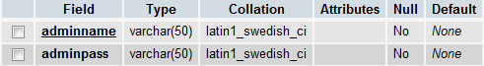

IMPORTANT NOTE: - for the database connection, I have kept the username as “root” and password as “”.